Manual Test Plan

Brief:

Snake will die if it hits it self or wall.

Your goal is to eat as much fruit as possible while keeping alive.

Speed will increase whenever you eat an apple

Keyboard:

UP DOWN LEFT RIGHT arrow key to change direction for snake 1

W A S D to change direction for snake 2

Click P once to pause the game, click P again to resume the game.

Test: initial configuration:

Click on the green triangle run Application Icon to start a snake game. (or the StaticGUI function)

You should see a welcome Page. Click “OK” to proceed.

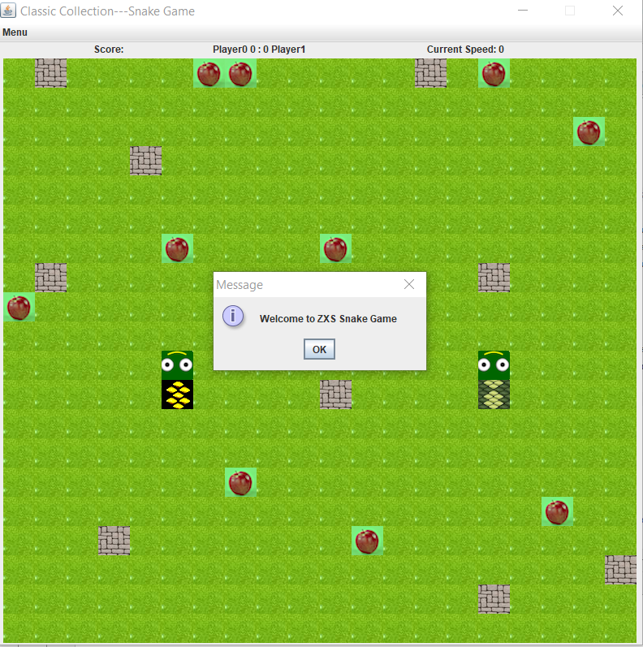

After clicking “OK”. You will be prompted to enter both players’ nickname.

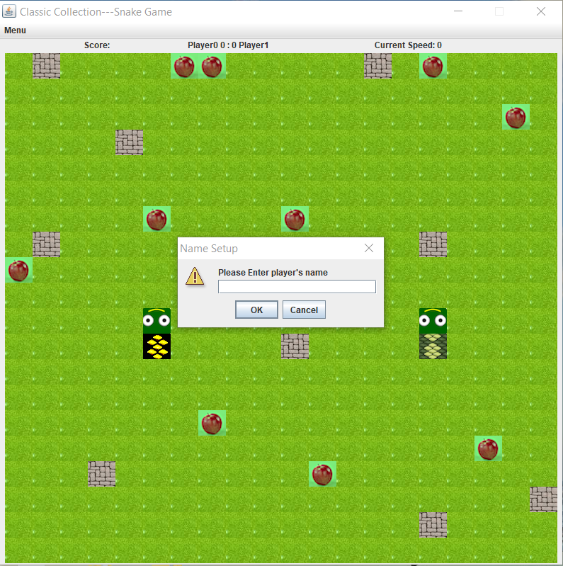

After clicking ok

You should see a default game board with a menu bar on the top. Hover the mouse over the menu bar to see menu items(Forfeit+Gameinfo+Restart)

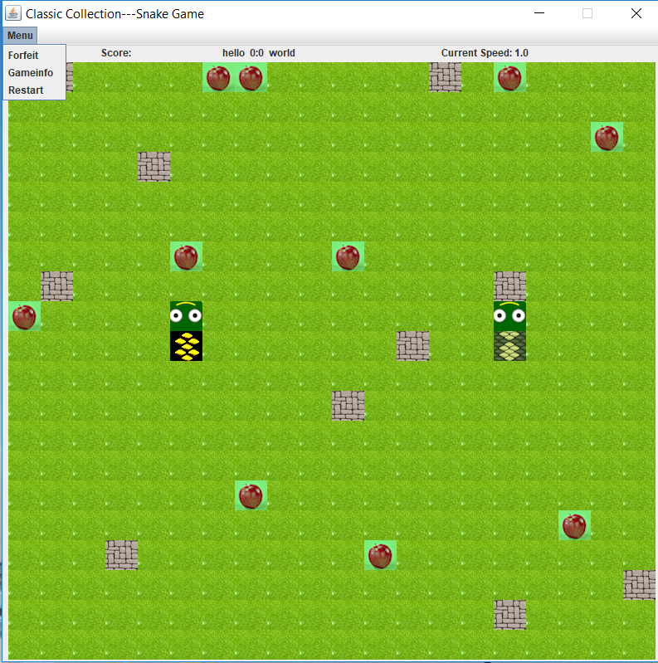

Test: Move the snake

Use arrow key on keyboard to change direction of snake 1(snake on the right).

Use WASD to change direction of snake 2 (snake on the left)

Every move will have both a visual effect on the gui screen and the console will show the step in text form.

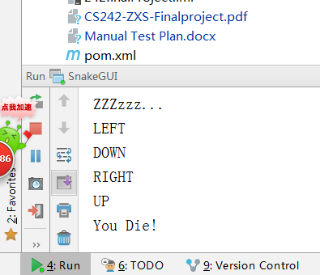

The Snake can only make valid movements. If the player try to move against rules, there

will be error message in the console saying that this is an invalid move. For example, If player press Down button while the snake is moving up.

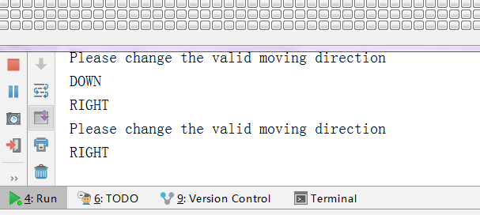

Test capture. Make sure fruit disappear after being eaten by snake. And the length of snake became one block larger.

Before: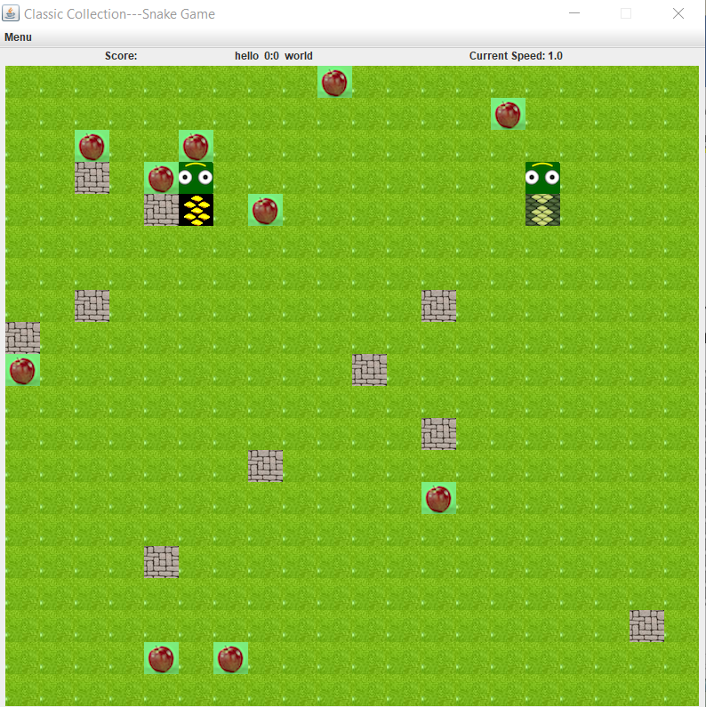

After eating an apple

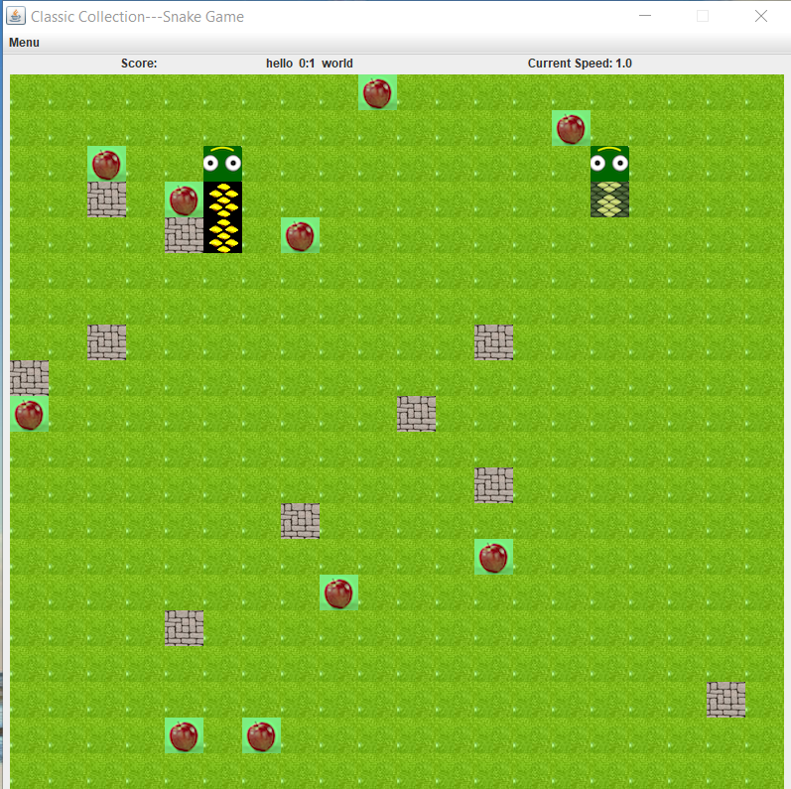

Test Pause/Resume

Click P once to pause the game, click P again to resume the game.

The Console will showing “ZZZzzz..” indicating the game is paused.

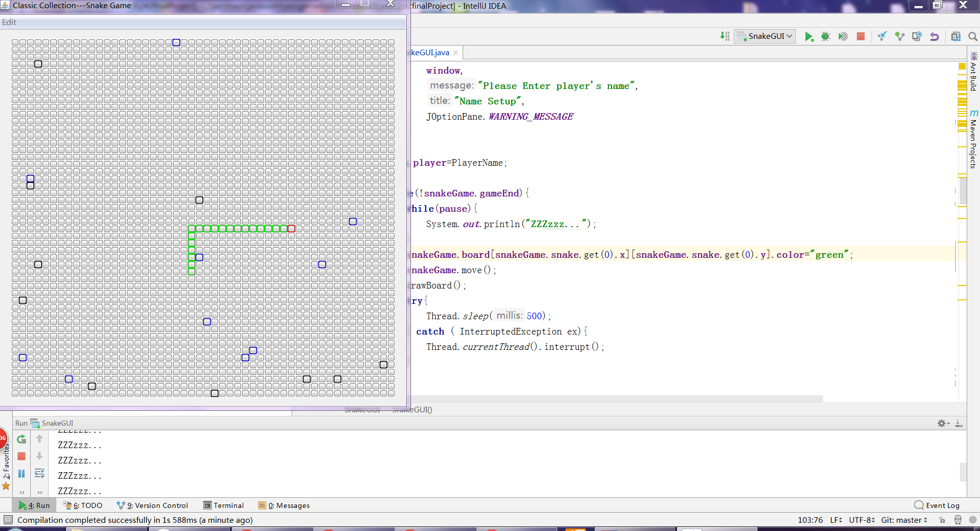

Test Score-User interaction

If player wants to see current scores and nicknames...

You can see it from the scoreboard above, as well as the current speed

C:\Users\laosh\AppData\Local\Temp\1524500541(1).png

Test : Restart Game

click the restart button, a new game will begin

Test : Forfeit

A player is allowed to forfeit a game at any point in time. Click the forfeit button in edit menubar. One “are you sure” message will pop up. Click yes.

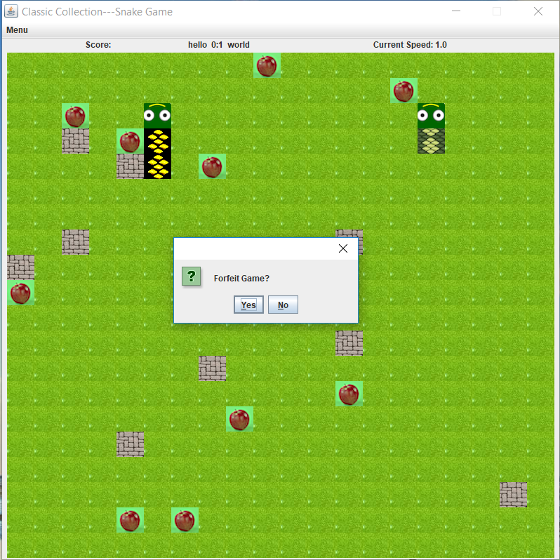

Test game end situation:

An popup message will tell you which player wins

